Cavisson Audit & Access Log

GMF Cybersecurity

Copyright © 2026, Cavisson Systems Inc.
All Rights Reserved. No part of this document shall be reproduced, stored in a retrieval system, transmitted by any means electronic, mechanical, and photocopying, or otherwise without written permission from Cavisson. No patent liability is assumed with respect to the use of the information contained therein.

Overview 3
Apache Tomcat Access Logs 3
Source System 3
Log Purpose 3
Sample Access Log Entry 4
Cavisson Audit Logs 5
Source System 5
Log Purpose 5
Audit Log Format 6
Compliance & Audit Use Cases 6
Contact Information 6

Overview
This document defines the logging architecture, structure, retention strategy, and Splunk ingestion framework for Apache Tomcat Access Logs and Cavisson Audit Logs within the organization.This document describes how Cavisson platform logs support cybersecurity, compliance, and audit requirements by providing complete traceability of authenticated user activities, HTTP access tracking, long-term log retention, secure SIEM integration, and structured audit-ready log formats.
This document describes:
- Structure and format of Apache Tomcat access logs
- Structure and format of Cavisson audit logs
These logs are required for:
- Security audit
- User activity tracking
- Operational troubleshooting
- Compliance monitoring

Apache Tomcat Access Logs

Source System
Application Server(for e.g.): Apache Tomcat
Location: /home/cavisson/work/apps/apache-tomcat-x.x.x/logs
Log File Pattern: localhost_access_log.YYYY-MM-DD.txt

Log Purpose
Tomcat access logs capture:
- HTTP requests received
- Client IP
- Request URL
- Response status
- Processing time
- User identity (if configured)

Sample Access Log Entry
172.17.0.1 - - [02/Mar/2026:08:29:13 +0000] "POST /DashboardServer/v2/web/dashboard/testRunStatusInfo?protocol=https&clusterNodeName=NDE&tomcatIP=66.220.31.142&tomcatPort=8021 HTTP/1.1" 200 10024 88 https-jsse-nio-0.0.0.0-7899-exec-493
172.17.0.1 - - [02/Mar/2026:08:29:19 +0000] "POST /DashboardServer/v2/web/dashboard/testRunStatusInfo?protocol=https&clusterNodeName=NDE&tomcatIP=66.220.31.142&tomcatPort=8021 HTTP/1.1" 200 10026 88 https-jsse-nio-0.0.0.0-7899-exec-491
172.17.0.1 - - [02/Mar/2026:08:29:20 +0000] "GET /DashboardServer/v2/web/common/getNodeHealthStatus?TSInSec=1772440160&nodeName=NDE&master=true HTTP/1.1" 200 2 2 https-jsse-nio-0.0.0.0-7899-exec-520
172.17.0.1 - - [02/Mar/2026:08:29:21 +0000] "GET /DashboardServer/v2/web/alert/events?tr=22222 HTTP/1.1" 200 40 376 https-jsse-nio-0.0.0.0-7899-exec-508
172.17.0.1 - - [02/Mar/2026:08:29:21 +0000] "GET /DashboardServer/v2/acl/session/validate?clientLastUpdatedTimeStamp=1772437666801&requestFromSAML=undefined&oktaGroupList=null&protocol=https&clusterNodeName=NDE&tomcatIP=66.220.31.142&tomcatPort=8021 HTTP/1.1" 200 237 50 https-jsse-nio-0.0.0.0-7899-exec-490
172.17.0.1 - - [02/Mar/2026:08:29:31 +0000] "POST /DashboardServer/v2/web/dashboard/testRunStatusInfo?protocol=https&clusterNodeName=NDE&tomcatIP=66.220.31.142&tomcatPort=8021 HTTP/1.1" 200 10020 88 https-jsse-nio-0.0.0.0-7899-exec-497
172.17.0.1 - - [02/Mar/2026:08:29:32 +0000] "GET /DashboardServer/v2/web/common/global-timebar/time?tr=22222&running1=true&st=1770987286000&duration=295980000&prodType=Netdiagnostics&sp=LIVE5&running=true&cmt=true&zoneId=Asia/Kolkata&protocol=https&clusterNodeName=NDE&tomcatIP=66.220.31.142&tomcatPort=8021 HTTP/1.1" 200 7 47 https-jsse-nio-0.0.0.0-7899-exec-516
172.17.0.1 - - [02/Mar/2026:08:29:38 +0000] "POST /DashboardServer/v2/web/alert/history/filter?level=-1&cavToken=Ud07NO3fd8Hpyb9QixDJLxSzI%2FuaqAaq9pdyw16Vc%2FzzvFK88GiR308n0EtdkkkOdZ%2FyEZAyGEIhnGN9wKwXizVeGOvsXd1Ygzs6wG7fzD%2BoTrwE3S0Dx6NCMK99O6PXuaWVQ0CUstmd%2BTkidxMttJsidmQx%2B5XFw%2FcmFf0Kk%2Bc%3D&protocol=https&clusterNodeName=NDE&tomcatIP=66.220.31.142&tomcatPort=8021 HTTP/1.1" 200 28 964 https-jsse-nio-0.0.0.0-7899-exec-443

Cavisson Audit Logs
All user activities within the Cavisson platform are registered under the Audit Logs module for detailed tracking and compliance purposes. The audit logs are generated for each user and captures how they interact with the platform’s features and captures vital information like user information consisting of the username, IP address etc, when the user performed login logout operations, modules accessed by the user, the activities done on the said modules.
This information proves to be vital in terms of identifying all types of interactions done by the user on the Cavisson platform. Below is a sample screenshot of the audit logs section:
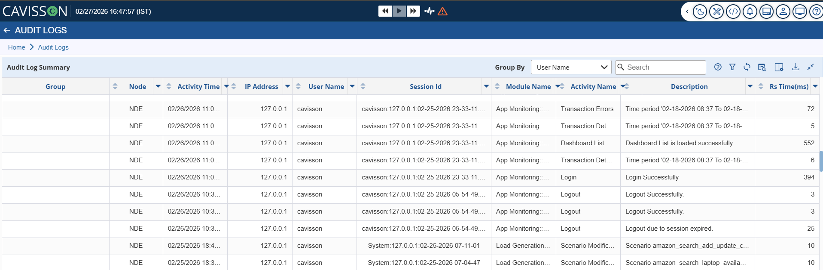
Fig 1: Audit Log Summary for users capturing detailed info.

Source System
Monitoring platform: Cavisson
Location:/home/cavisson/work/.productLogs/.auditLogs
Log filename:
- audit-Error.log
- audit-Debug.log

Log Purpose
Audit logs track:
- User authentication events
- Configuration changes
- Test executions
- Dashboard modifications
- Administrative actions

Audit Log Format
Following
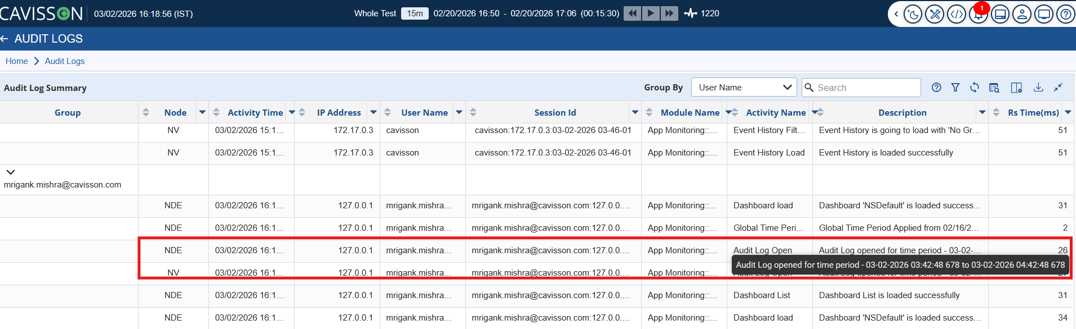

Compliance & Audit Use Cases
Logs support:
- User traceability
- Security investigation
- Test execution auditing
- Incident RCA
- Compliance reporting

Contact Information
Team | Responsibility
Cavisson Team | Tomcat logs
Cavisson Team | Audit logs
Observability Team | Splunk ingestion

