

PoC Report

Honda Cars

PoC Duration – 13th Aug to 30th Aug 2025

Copyright © 2025, Cavisson Systems Inc.
All Rights Reserved. No part of this document shall be reproduced, stored in a retrieval system, transmitted by any means electronic, mechanical, and photocopying, or otherwise without written permission from Cavisson. No patent liability is assumed with respect to the use of the information contained therein.
Contents
Introduction 2
Key PoC Details: 2
System/Infrastructure Monitoring 3
Memory Statistics: 4
Disk Statistics: 4
Database Monitoring 5
Database Query Statistics & Details 5
Database Locks 6
Database Sessions 7
I/O by File 8
Conclusion 9

Introduction

Cavisson System’s APM product, NetDiagnostics, was deployed at Honda Cars, India for establishing the monitoring of critical application and underlying infrastructure to identify the root cause behind any exception or slowness observed in the said application.

The following capabilities were successfully demonstrated to the Honda team, as mentioned in the PoC Proposal document:
Honda Cars Observability PoC Scope
Capability | PoC Coverage
Server Monitoring | Yes
Detailed Database Monitoring | Yes
Log Monitoring | Yes
Alerting & Notification | Yes

This Proof-of-Concept (PoC) report further details the observations made by Cavisson’s end-to-end observability platform for Honda Cars.
Cavisson’s server was deployed at Honda data center facilitating easy communication between Cavisson’s agents and the controller to provide a single pane for accessing all end-to-end observability data for one click correlation and context-based issue identification.

Key PoC Details:
PoC Duration: 28th May to 13th June 2025
  - Deployment Details:
Under this PoC, two servers, viz; hilifetest and hilifedev were monitored along with the required databases (CDBW1 and CDBDEV):
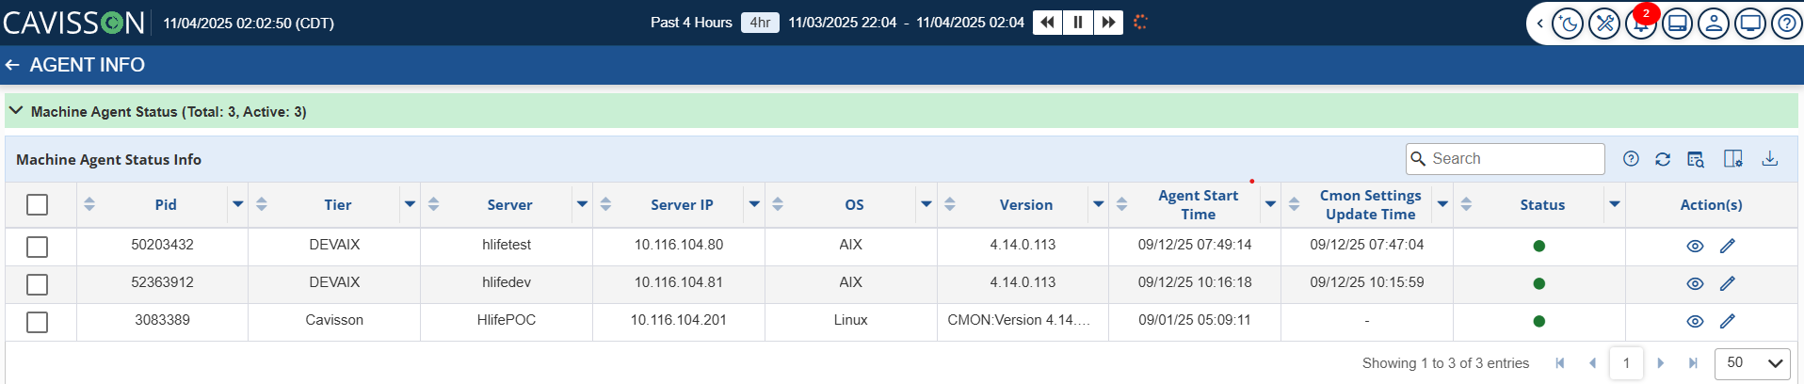

For enabling detailed monitoring of the target Oracle database, basic permissions were given to the cavisson user that then facilitated the capturing of in-depth database information like locks, blocking session, query/execution plan, I/O by file among other details listed in this report.

Infrastructure/database metrics and logs were collected via Cavisson’s OneAgent without the need to deploy multiple agents.

